

University of Bahrain

College of Information Technology

Department of Computer Science

ClickVenture Web Application

Prepared by

Ali Fikri El Mikdadi 20202155

Abdullah Aktham Khaleel 202004678

Elbashir Fathi Abdalla 202002196

For

ITSE 498

Senior Project

Academic Year 2023-2024-Semester 2

**Project Supervisor:** Dr. Faisal Al Khateeb

14 – 5 – 2024

# Abstract

// The Abstract is a 50-150 words that gives a precise and concise summary of the work accomplished including any performance measures. The first sentence in the Abstract is the most important and should be chosen carefully, e.g. The abstract should allow the reader who is unfamiliar with the work to gain a swift and accurate impression of what the project is about, how it arose and what has been achieved.

Temporary Abstract for brainstorming

~~A groundbreaking web application for tour planning, originating in Bahrain, is showcased in this project. Users are able to upload trip plans & captivating photos and share insights on landmarks, allowing them to earn redeemable points. Key features, such as upvoting, rating, and a leaderboard for top contributors, are incorporated. Businesses benefit from advertisement on the platform and more potential customers engagement and enhanced visibility, while revenue of the web application is generated through registration fees imposed by the sponsoring company of the website. This symbiotic relationship fosters a thriving community of tourism and businesses, ensuring mutual benefits and sustainable growth for all parties involved.~~

// Read then remove the paragraphs that starts with “//”

// Make sure that you have read all comments in this template before you delete them

// Remove all tables and figures included in this template that are not related to your project before printing out the report.

// Remove all appendices included in this template and add your appendices.

# Acknowledgements

// This section includes any words of appreciation and gratitude to the people helped with accomplishing the project. Keep the acknowledgement short.

**List of Content**

Abstract Error! Bookmark not defined.

Acknowledgments Error! Bookmark not defined.

List of Tables Error! Bookmark not defined.

List of Figures Error! Bookmark not defined.

Chapter 1 Introduction Error! Bookmark not defined.

1.1 Problem Statement **Error! Bookmark not defined.**

1.2 Project Objectives **Error! Bookmark not defined.**

1.3 Relevance/Significance of the project **Error! Bookmark not defined.**

1.4 Report Outline **Error! Bookmark not defined.**

Chapter 2 Literature Review Error! Bookmark not defined.

Chapter 3 Project Management 16

3.1 Process Model **Error! Bookmark not defined.**

3.2 Risk Management 18

3.3 Project activities Plan 20

Chapter 4 Requirement Collection and Analysis 21

4.1 Requirement Elicitation 21

4.2 System Requirements 27

4.3 Personas 27

4.4 System Models 29

Chapter 5 System Design 35

Chapter 6 System Implementation and Testing 53

Chapter 7 Conclusion and Future Work 54

References Error! Bookmark not defined.

Appendix A Compact Disk material 57

Appendix B Format Guideline 58

# List of Tables

# List of Figures

# Chapter 1

# Introduction

Presenting an innovative web application revolutionizing tourism in Bahrain and beyond. This dynamic platform allows users to craft and share detailed trip plans alongside captivating photos, fostering an interactive community of travelers and enthusiasts. By engaging in activities such as upvoting, rating, and leaderboard participation, users earn redeemable points, enhancing their standing within the community. Meanwhile, businesses capitalize on increased visibility and customer engagement, facilitated by targeted advertisement opportunities. Revenue streams are diversified through registration fees imposed by the sponsoring company. As the platform evolves, plans include incorporating an AI-driven Trip Planner to further personalize user experiences. This holistic approach cultivates a mutually beneficial ecosystem, stimulating internal tourism and propelling business growth.

## **1.1 Problem** Statement

// Present the statement of the problem that is going to be investigated throughout the project, the problem can be divided into two to three sub-problems to be able to easily solve the whole problem.

**The main problems this project aims to investigate are highlighted below:**

**Limited engagement on traditional trip planning platforms:** Low interaction rates and decreased interest in the procedure for planning are the results of traditional trip planning platforms' frequent inability to properly engage users. These platforms could seem old-fashioned to users or devoid of engaging features that keep them interested during the planning process. Users are less likely to spend time and energy researching their options or finishing their travel plans if they are not actively involved.

**Overwhelming trip planning processes:** For many people, the process of trip planning can be too complicated, especially when there are so many choices available for a place to stay activities, and transportation. Making decisions can become tiresome and frustrating when sifting through numerous websites and resources in search of information. Users could find it difficult to accelerate the planning process and make well-informed decisions that fit their preferences and financial constraints in the absence of clear direction or assistance.

**Lack of guidance for users:** Many travel planning websites don't provide consumers with enough instructions or support resources to help them along the way. Users could feel as though they are on their own in navigating the abundance of options, which could cause ambiguity and indecision. It could be difficult for consumers to plan an itinerary that satisfies their needs and expectations without access to professional help or tailored recommendations.

**Time-consuming research required for trip planning:** A lot of research is frequently needed while planning a vacation in order to compile details about the locations, activities, lodgings, and attractions. Before making a choice, users might need to look through a variety of sources, read reviews, and compare costs. This drawn-out procedure may discourage consumers from utilizing trip planning apps to their full potential and result in hurried or incomplete vacation arrangements.

**Absence of real-time assistance during the planning phase:** It is possible for users to run into problems or queries throughout the trip planning stage that call for quick support. However, real-time assistance options are sometimes lacking typical trip planning tools, leaving customers feeling lost or uncertain about what to do next. Users may grow irritated and lose interest in the planning process if they are unable to get prompt support, which could negatively affect their entire trip experience.

These difficulties emphasize the demand for a feature-rich and intuitive travel planning system such as ClickVenture. With the use of cutting-edge technologies like an AI-powered ChatBot trip planner, an incentive points system, and carefully chosen deals and offers, ClickVenture hopes to transform how users plan and record their trips throughout their journeys in Bahrain.

## 1.2 Project Objectives

// The aim and objectives of the project are outlined to provide a short description of what the researcher intends to achieve, in addition, a statement of the limitations of the scope of the research is also presented.

The following goals are the focus of this project:

**Boost User Engagement:** Look into ways to make users more interested and engaged on platforms for trip planning, considering the issues of low user interaction.

**Simplify Tour Planning:** Create plans to make tour planning less complicated and overwhelming for users by cutting down on the number of alternatives and choices they must make.

**Offer personalized Guidance:** Develop tools to give users personalized guidance and support at every stage of the planning process in order to alleviate the lack of expert advice and assistance on conventional platforms.

**Reduce the Research Burden:** Look for ways to reduce the amount of time and energy consumers must spend researching trips in order to relieve the strain of compiling a lot of information.

**Provide Real-Time Support:** Establish systems that allow users to get real-time support and assistance while they plan, reducing the annoyance that comes with waiting for assistance on traditional platforms.

## 1.3 Relevance/Significance of the project

// The relevance and the significance of the project should be synthesized in this section.

This initiative is significant because it has the ability to address important issues that tourists and tourism-related businesses in Bahrain and elsewhere confront. Through the revolutionary trip planning experience that ClickVenture offers, the initiative hopes to improve user involvement, expedite the planning process, and offer tailored advice and support. This enhances the user experience in general and has greater potential for boosting tourism and sparking Bahrain's economy. Furthermore, ClickVenture's cutting-edge features and capabilities, including its AI-powered ChatBot trip planner and its awarding points system, have the potential to revolutionize the way travelers plan and record their travels and create a thriving community of enthusiasts. Ultimately, the project's significance goes beyond the travel and tourist sector; it advances technology-driven solutions and encourages user-business engagement in the digital age.

## **1.4 Report Outline**

// Briefly outline the remainder of this report in a paragraph. For example, Chapter 2 scans the literature related to the studied problem. Chapter 3 describes the research model adopted in the project and the hypotheses to be tested. Etc.

* **Chapter 2: Literature Review**

Carries out an extensive analysis on existing similar systems, and highlights the technologies to be utilized by our project.

* **Chapter 3: Project Management**

Delves into the project management methodology, encompassing the process model, risk mitigation techniques, and the project activity plan.

* **Chapter 4: Requirement Collection and Analysis**  
  Covers topics like requirement elicitation, system requirements, personas, and system models as it explains the requirement collecting and analysis process.
* **Chapter 5: System Design**  
  Describes the architecture and design choices made for the cutting-edge web application ClickVenture.
* **Chapter 6: System Implementation and Testing**  
  Highlights the development process and evaluation techniques used in the project's implementation and testing phases.
* **Chapter 7: Conclusion and Future Work**  
  Highlights important conclusions, discusses ramifications, and recommends directions for more study and improvement.
* **References and Appendix**   
  includes a list of all the references used in the report, along with any supplemental information or project-related facts and information.

# Chapter 2

# Literature Review

// The main reason behind having a review of related literature is to position the study in the context of what has been done before, what is currently happening, and how research in this area is conducted. To start, provide a brief history of previous researches and practices, and then review the current theory and practices. Critical writing is about providing reasons to support an argument. Therefore, discuss the sources, identify their points of view, provide arguments, support arguments with evidence, and finally draw conclusions and present your point of view in a structured, clear, well-reasoned way. The structure of the chapter is open to students. This chapter needs to be carefully structured to produce a good introduction to the project and shows the location of the project within the literature.

## **2.1 Related Work**

Research on the most pertinent systems that resemble ours is presented in this section. It gives a general rundown of these systems' capabilities, identifies their best attributes, and points out any areas for improvement.

2.1.1 Pickyourtrail:

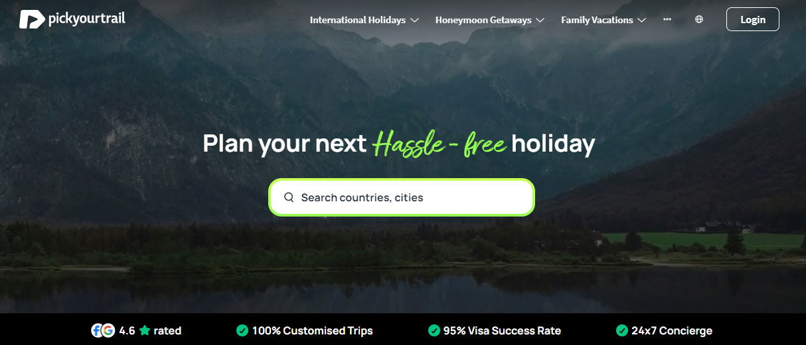

**Advantage:**

Pickyourtrail is a well-known platform in the travel sector, distinguished by its user-friendly interface and customizable trip itineraries. With an emphasis on customization and user experience, it enables passengers to create custom travel schedules that fit their tastes, hobbies, and financial constraints.

**Disadvantage:**

Although Pickyourtrail has a lot of customization options, users may need to invest more time and energy in its personalized approach than they would on more conventional trip planning platforms. Furthermore, the platform's premium features might be more expensive, which would restrict accessibility for tourists on a tight budget.

**2.1.2 TripAdvisor:**

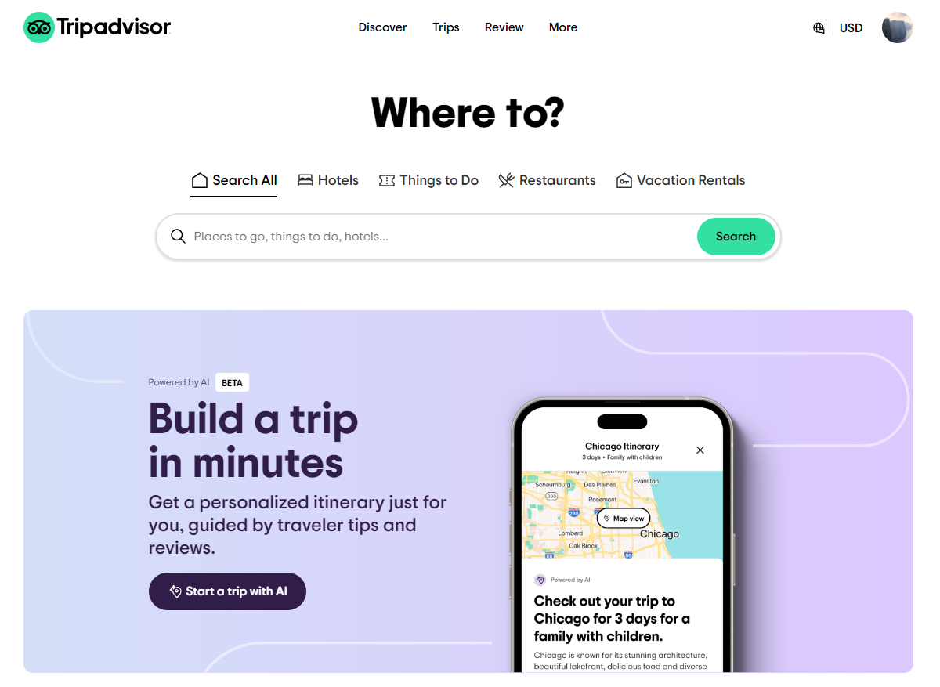

**Advantage:**

TripAdvisor has made a name for itself as the resource that tourists turn to when looking for in-depth information, reviews, and suggestions. With a vast library of user-generated material, it offers insightful advice and helpful trip planning information for a variety of locations, lodging options, and activities.

**Disadvantage:**

TripAdvisor's reliance on user-generated material may lead to inconsistent quality and dependability of reviews, despite its abundance of information. When using outdated or biased information, users run the risk of having different expectations from what they really experience when traveling.

**2.1.3 Unipal:**

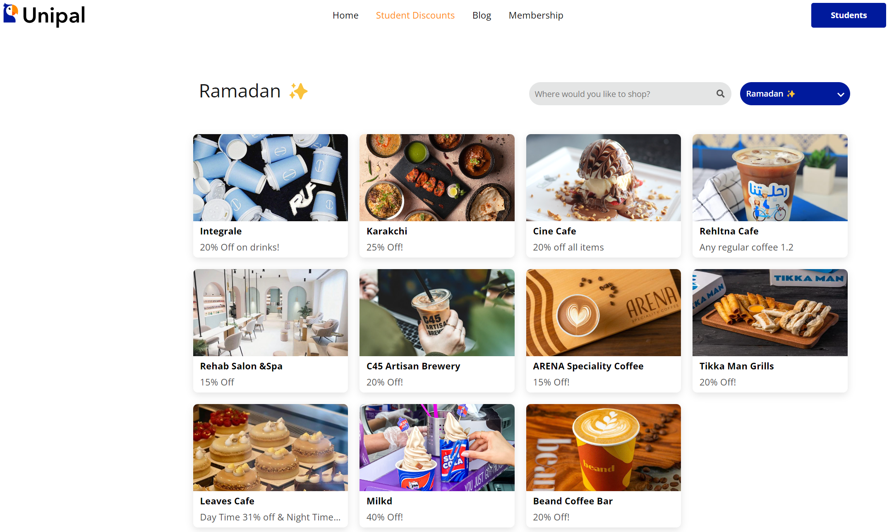

**Advantage:**

Unipal provides a unique student-oriented approach to trip planning, having been specifically designed with the needs and interests of student travelers in mind. Its focus on things that matter to students, like reasonably priced options and youth-oriented activities, may appeal to this demographic. Additionally, by offering opportunities to save money on accommodations, activities, and transportation, its discount programs promote student travel.

**Disadvantage:**

Its focus on features targeted at students may attract a particular group of people, but it might also make it less applicable to a wider range of users. Because the platform does not provide solutions that meet their diverse needs and interests, non-student travelers may find it less relevant or inclusive.

These platforms, each with their own benefits and drawbacks in the highly competitive tourism business, have completely changed the way travelers plan and enjoy their trips. In order to overcome these obstacles and close the gap between various tour planning systems, ClickVenture works to improve the overall trip planning experience for users of all interests and backgrounds by utilizing the advantages of current platforms and including new features. ClickVenture's point and reward system can benefit from incorporating components from Unipal's discount systems to give users even more incentives and an improved overall experience.

## 2.2 User Behavior on Travel Sites

According to recent research, user engagement on travel platforms is highly dependent on the personalization of content and the ease of use of the interface. According to research by Smith and Johnson (2023), platforms that use user data to customize recommendations have engagement rates that are 30% greater than those that don't. This emphasizes how crucial modern data analytics are for anticipating and comprehending user preferences, which can be essential for enhancing user interfaces in travel applications on an ongoing basis.

## 2.3 Effect of User Interface Design on User Satisfaction:

On digital platforms, user satisfaction and retention are greatly influenced by the design of user interfaces. Lee et al. (2022) claim that a well-designed user interface can increase user satisfaction by up to 40% by facilitating information accessibility and ease of navigation. These results imply that spending money on UX/UI design has a major impact on the useful usability of travel planning systems in addition to providing a pleasing visual experience.

## 2.4 Web Development Tools & Technologies

Choosing the right tools and technologies is essential when creating web applications for the tourism sector in order to meet the specific needs of scalability, user interaction, and real-time data processing. This review covers the more general categories and trends in technology choices, with an emphasis on the justifications for the selections of particular technologies that improve the functionality and user experience of ClickVenture-like platforms. This in turn allows us to follow the industry standards.

* **Frontend and User Interface Development:**  
  ClickVenture makes use of TypeScript because of its static typing, which improves the dependability and maintainability of the code. This is in line with the most recent developments in dependable and scalable frontend development frameworks that guarantee program dependability. Because of React.js's modular nature, ClickVenture uses it for the user interface, making it possible to create engaging and dynamic user experiences. Material-UI (MUI), which is a rich set of customizable components based on Google's Material Design, is used to complement React. This combination guarantees a consistent and user-friendly design that satisfies the needs of contemporary travelers while also enhancing ClickVenture's visual attractiveness and usability.
* **Database management:**

NoSQL databases, like MongoDB, serve applications that need fast scalability and flexible data storage to handle the kind of vast, varied data sets that are common in travel and tourist platforms. They are perfect for dynamic content, which is common in user-centric travel applications, because they can manage unstructured data.

* **Server-Side Scripting:**

Node.js is utilized because of its non-blocking I/O paradigm and effective handling of asynchronous events. These features are crucial for online applications that need to process data in real-time and at high throughput, as those in the travel sector.

* **Integrating APIs:**

This demonstrates how external services are used to improve functionality and user interaction. Examples of integrated APIs are Google Maps, which visualizes geographic data, and chatbots, which automatically communicate with customers. Travel planning becomes more interesting and accessible with the help of these APIs, which also improve user experience by streamlining the interaction process.

# Chapter 3 Project Management

// This chapter highlights the project activities to meet the project requirements. It includes the process model as a set of related activities that leads to the production of the software/system. In addition, this chapter identifies the risks that may threaten the project that is being developed. The chapter usually ends with the project activity plan most commonly created by “Gants Charts” and “Project Tasks” of phases of the project.

The main project management methods and procedures used in the project's development are described in this chapter. It begins with an outline of the chosen software process model and a rationale for the selection. Next, focus shifts to risk management, which includes identifying possible risks and developing plans of action to reduce these difficulties during the course of the project. A thorough plan is also provided to manage and mitigate any possible hazards during the course of the project. The project activities plan, which outlines every job and activity required for system delivery within a certain timeline, finally brings the chapter to a close.

The following subsections are examples for the subsections that can be added in this chapter

// This section describes the software process model which is also known as Software Development Life Cycle model. It introduces the selected model for the development process with justifications.

## 3.1 Process Model

ClickVenture uses the Agile development style, which is ideal for projects like web applications in the travel sector where needs change regularly. In order to maintain the product's relevance and user-centricity by ongoing evaluation and incorporation of user feedback, this model places a strong emphasis on extensive cooperation, frequent delivery, and iterative development.

**Iterative Development:**

* Description: The project is organized into short sprints, typically lasting two to four weeks, which allows for flexibility and regular feedback integration. This approach facilitates regular reassessment of project priorities and immediate incorporation of user input, which is critical in the fast-evolving travel sector.
* Application: During each sprint, specific, achievable goals are set, such as developing particular features or improving existing functionalities. The progress of these goals is reviewed at the end of each sprint, assessing whether the goals have been met and planning the subsequent steps.

**Continuous Collaboration:**

* Description: Agile insists on maintaining ongoing collaboration throughout the project lifecycle. This involves consistent communication and frequent planning sessions with the project team, which include any collaborating peers and potentially a supervisor or mentor.
* Application: Regular meetings, such as weekly or bi-weekly scrums, are held to discuss progress, address challenges, and gather feedback. These sessions ensure that all team members remain aligned with the project's current status and future direction.

**User-Centered Feedback:**

* Description: Agile places significant importance on incorporating user feedback into the development process. This feedback loop is crucial for ensuring the application meets the needs and expectations of its end users.
* Application: User testing sessions are conducted at the end of each sprint, inviting peers, faculty, or potential users to interact with the application and provide feedback. Additionally, online surveys or feedback forms can be employed to gather broader input. Feedback received is critically evaluated during sprint reviews, leading to necessary adjustments that enhance user experience and application functionality.

Implementing Agile in a student project involves adapting its methodologies to fit within the academic environment and resources available. The focus is on ensuring that learning and development progress hand in hand with project execution. This adaptation includes simplified tools and techniques that suit a smaller scale project without compromising on the essence of Agile practices.

The successful application of Agile in ClickVenture will ensure the project not only meets the educational objectives but also results in a high-quality, market-responsive product that is built through an iterative, collaborative process informed by real user feedback.

## Risk Management

// This section identifies the potential risks that may be faced during the project and the necessary plans to minimize them.

Several potential risks could surface throughout ClickVenture's development, affecting the project's progress, quality, and ultimately the web application's success. It's critical to recognize these hazards in advance and put the right precautions in place to lessen their effects. The following are some of the major risks and the accompanying risk management techniques:

1. **Technical Risks:**

**Risk:** During development, technical difficulties such compatibility problems with various browsers and devices, security flaws, and scalability issues could surface.

**Mitigation:** To guarantee compatibility, thoroughly test your application on a variety of devices and browsers. To protect user data, put strong security measures in place, such as authentication procedures and encryption. Consider scalability when designing architecture and make use of scalable infrastructure or cloud services.

1. **Resource Constraints:**

**Risk:** The delivery and quality of a project may be impacted by a lack of resources, including time, and human resources.

**Mitigation:** Make sure team members get the support and abilities they need by allocating time wisely. Keep a careful eye on the project's timeline, see any possible bottlenecks early, and make any necessary adjustments. Set work and feature priorities to get the most out of your resources and cut down on project delays.

1. **Scope Creep:**

**Risk:** When the project's requirements stretch beyond the originally specified scope, a phenomenon known as scope creep occurs. This can result in longer project timelines, and lower project quality overall.

**Mitigation:** With feedback from stakeholders, clearly define the project's requirements and scope up front. In order to properly manage scope changes, implement change control procedures. Prior to authorizing adjustments, in consideration are the effects on the schedule and quality. Maintaining open communication with all parties involved in the project to control expectations and guarantee agreement.

1. **User Acceptance:**

**Risk:** A lack of awareness of user needs, insufficient user involvement, or a poor user experience could lead to low user acceptance or adoption of ClickVenture, which would impede its success significantly.

**Mitigation:** To comprehend user preferences, problems, and expectations, an in-depth user research and usability testing is required. To increase user happiness and adoption, iteratively incorporating feedback into the development process is done.

1. **Market Competition:**

**Risk:** Since similar platforms offer competing features and services, fierce competition from both established and up-and-coming businesses in the tourism industry could be difficult.

**Mitigation:** To determine the advantages and disadvantages of competitors, thoroughly analyze the market. Make ClickVenture stand out by providing distinctive features, tailored experiences, and creative fixes. Maintain a close eye on consumer preferences and market trends while modifying ClickVenture's product offerings to satisfy changing demands and beat out rivals.

Through the identification of potential risks and the implementation of appropriate risk management procedures, the project team can enhance the likelihood of ClickVenture's success and prevent bad repercussions. Throughout the project lifetime, proactive risk mitigation strategies and routine risk assessments are crucial to ensuring smooth progress and producing a high-caliber web application that lives up to user expectations.

## 3.3 Project activities Plan

// This section breaks down the project into different activities according to defined period of time needed to deliver the system.

Agile project management practices are continuous and cyclical, with an emphasis on providing value at the conclusion of each sprint. The following is the general outline:   
  
**Sprint planning:** The process of defining the next sprint's scope in relation to the product backlog and priority settings.   
**Daily Stand-ups:** Quick meetings held every day to go over the day's work, plan the progress, and resolve any problems.   
**Development Work:** Within the sprint, concentrated times for design, coding, and testing.   
**Sprint Review:** The team delivers the increment to stakeholders at the conclusion of each sprint, gets their input, and makes any required changes.   
**Sprint Retrospective:** The team evaluates their procedures and makes suggestions for future iterations.

|  |  |  |  |
| --- | --- | --- | --- |
| Sprint | Duration | Goals | Review |
| 1 | 1/3/2024 - 31/3/2024 | Define core functionalities and design the basic user interface. | Evaluate the design with the project team, adjust based on feasibility and initial feedback. |
| 2 | 1/4/2024 - 21/4/2024 | Develop a working prototype that includes key functionalities. | Conduct a peer review session to gather early feedback on usability and function. |
| 3 | 22/4/2024 - 2/5/2024 | Continue development of core functionalities and begin adding additional features. | Test the features with peers, refine based on their input. |
| 4 | 3/5/2024 - 14/5/2024 | Final integration and comprehensive testing; focus on bug fixing and usability enhancements. | Perform thorough testing, prepare for final presentation and gather final feedback for tweaks. |

**Chapter 4  
Requirement Collection and Analysis**

// The requirement gathering is an essential part of any project management. It is about creating a clear and agreed set of customer requirements that allow to deliver a system according to the customer requirements.

// This chapter discusses the functional and non-functional requirements of the system. It also discusses the data flow diagram and the use case diagram of the system.

// The chapter should start with an introduction followed by eventually the following subsections.

* 1. **Requirement Elicitation**

In the ClickVenture project, the requirement elicitation process was primarily conducted through an online survey to directly capture potential users' needs and expectations for a travel planning platform. Additionally, the development team employed various software development documentation techniques to further refine and structure the system requirements.

**Online Survey:** The survey was designed to gather quantitative data from potential users about their preferences for features such as interactive maps, social media integration, and personalized itinerary planning. This approach helped to directly capture the functionalities most valued by users.

**Software Development Documentation:** To complement the user data and enhance the system design process, the team utilized software development documentation methods, including UML (Unified Modeling Language) diagrams. These diagrams provided a visual representation of the system architecture, interactions between different system components, and user interactions. UML diagrams such as use case diagrams, activity diagrams, and sequence diagrams played a crucial role in structuring the system's functional requirements and ensuring a thorough understanding of the system flows and user interactions.

The combination of direct user feedback from the survey and detailed system modeling through UML diagrams ensured a robust foundation for developing a user-centric, efficient, and scalable travel planning platform. This dual approach facilitated the precise definition of both functional and non-functional requirements, guaranteeing that the development aligned closely with the needs of the target audience while adhering to best practices in software engineering.

### 4.1.1 Analyzing the Survey Results

The online survey conducted for ClickVenture revealed key insights into the demographics, preferences, and behaviors of potential users:

* **Demographics**: The survey indicated a near even distribution between male and female respondents, with a significant majority in the 18-29 age group, and most being university students or young adults. This suggests a young, tech-savvy user base for ClickVenture.

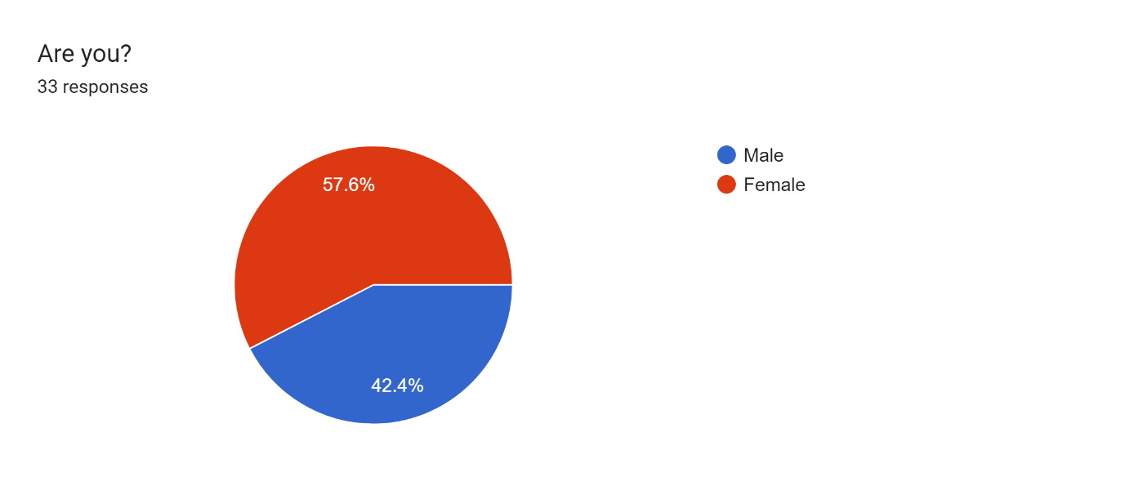

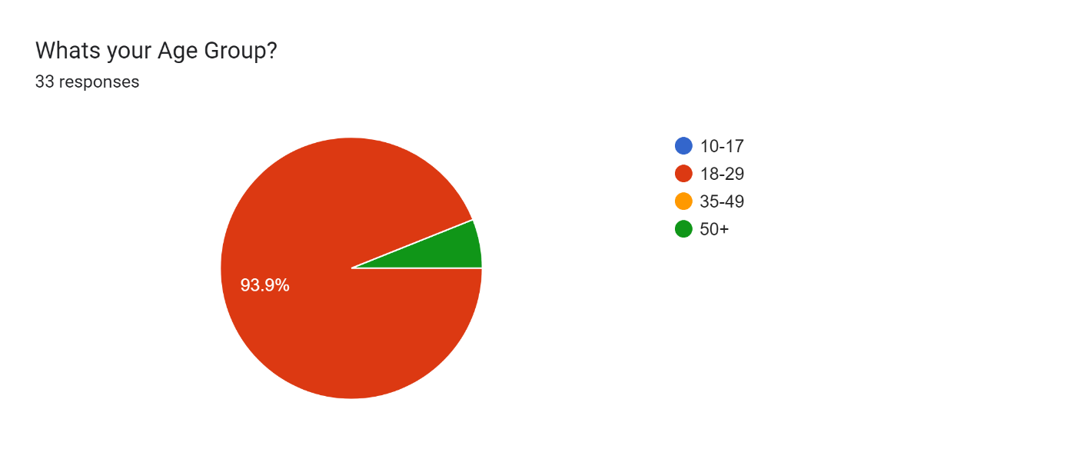

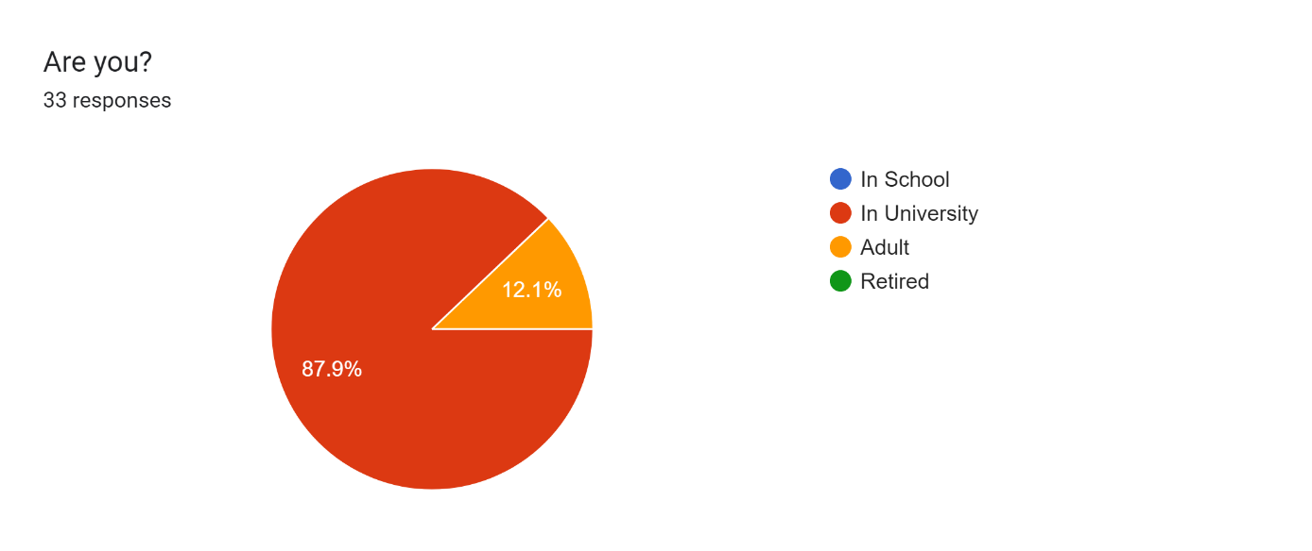

* **Previous Experience with Trip Planning**: Over 70% of respondents have used an online trip planner before, which implies a user base that is familiar with digital travel tools and has certain expectations for functionality and user experience.

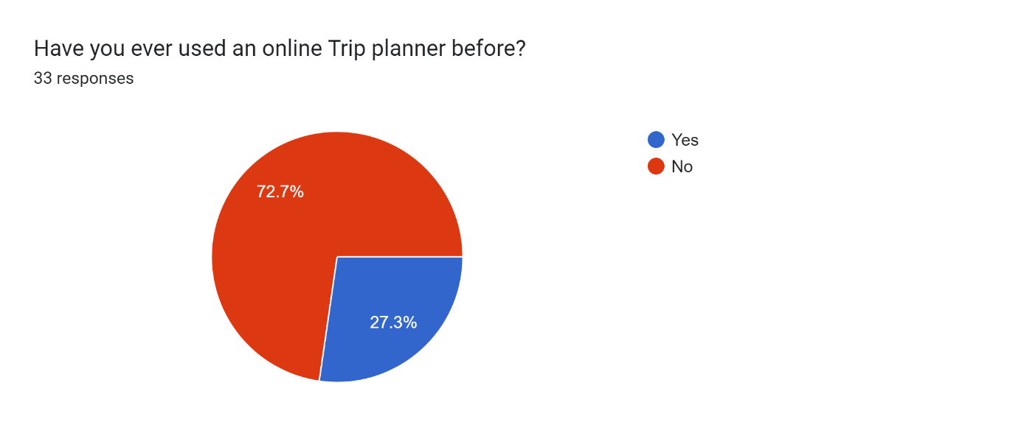

* **Activity Preferences**: A significant preference was shown for restaurants and entertainment options, suggesting that these categories should be well-represented in the ClickVenture platform.

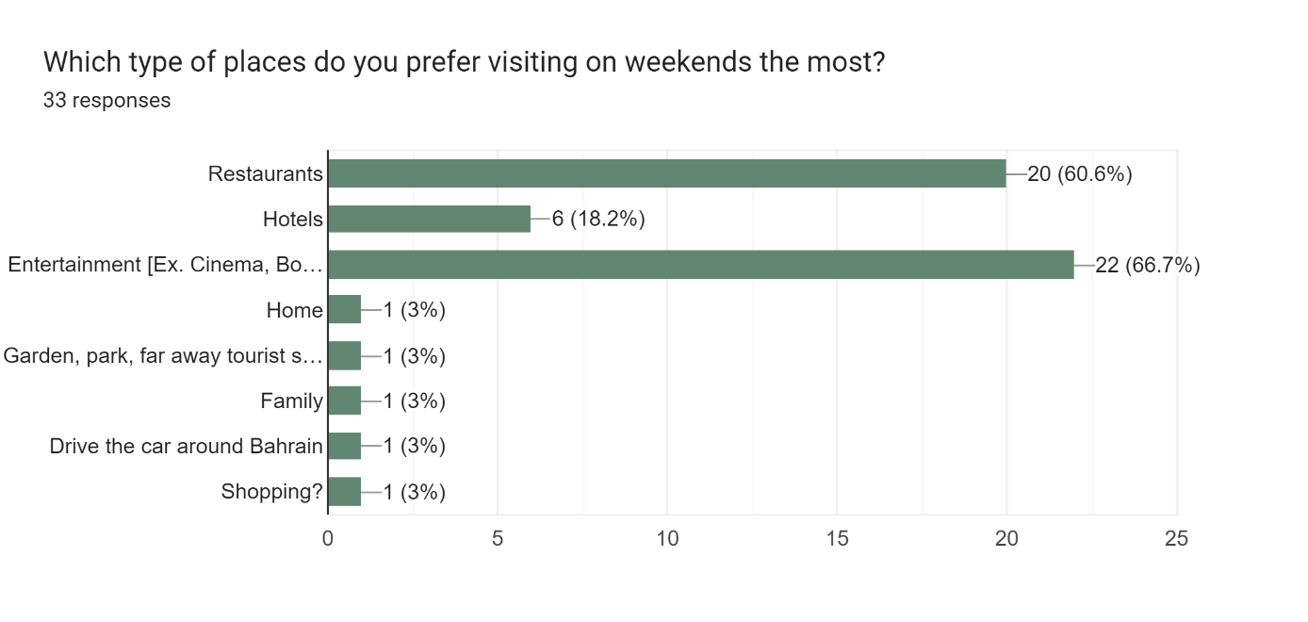

* **Indoor vs. Outdoor Preferences**: Respondents are split in their preference for indoor and outdoor activities, indicating the need for a diverse range of suggestions in trip planning to cater to different tastes.

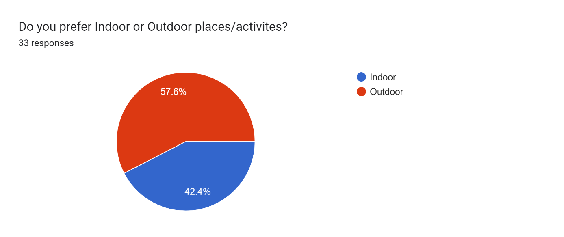

* **AI Assistance**: A majority of users are open to using AI for trip planning, highlighting an opportunity for ClickVenture to incorporate intelligent automation and personalization in its service.

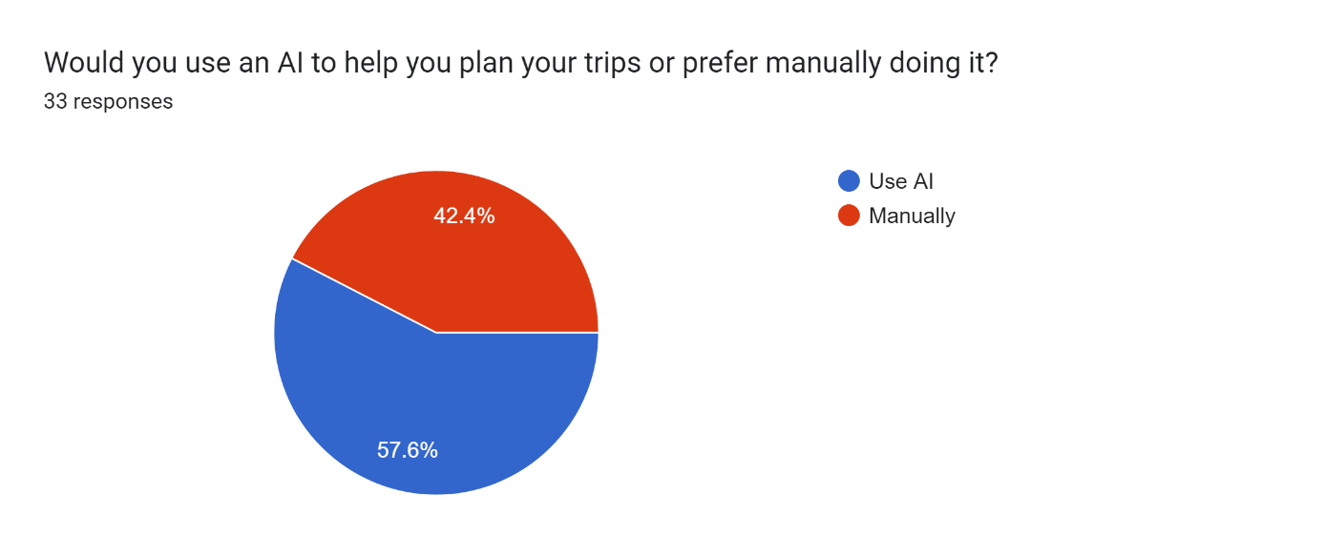

* **Sharing Preferences**: Respondents are most likely to share their travel plans with friends and family, rather than work colleagues, suggesting that social features should be geared towards personal networks.

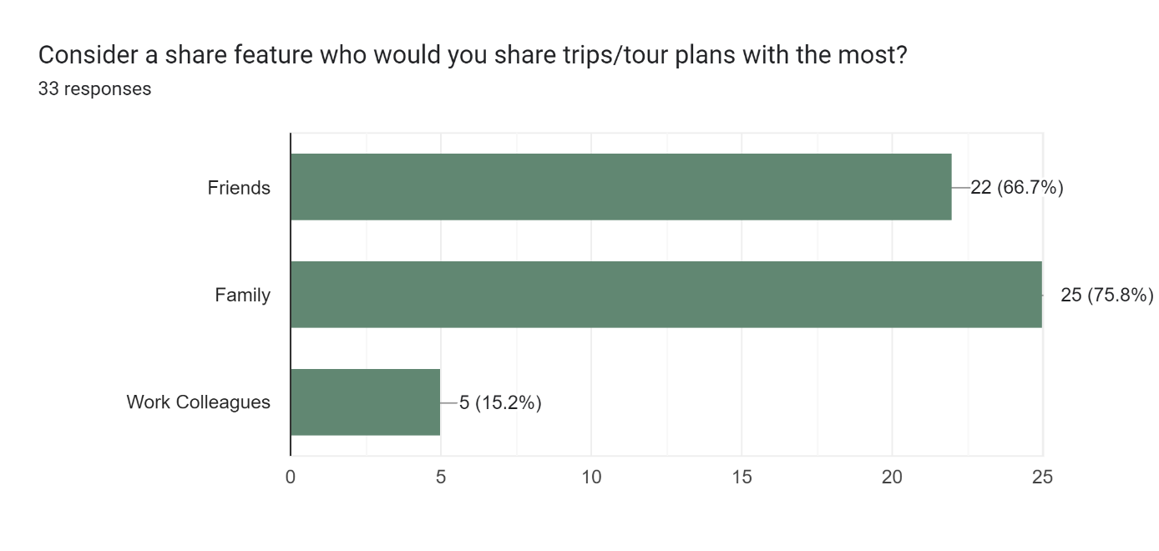

* **Awareness of Local Attractions**: Many respondents believe people struggle to know the best places to visit, which indicates a significant opportunity for ClickVenture to provide value by suggesting hidden gems and popular attractions.

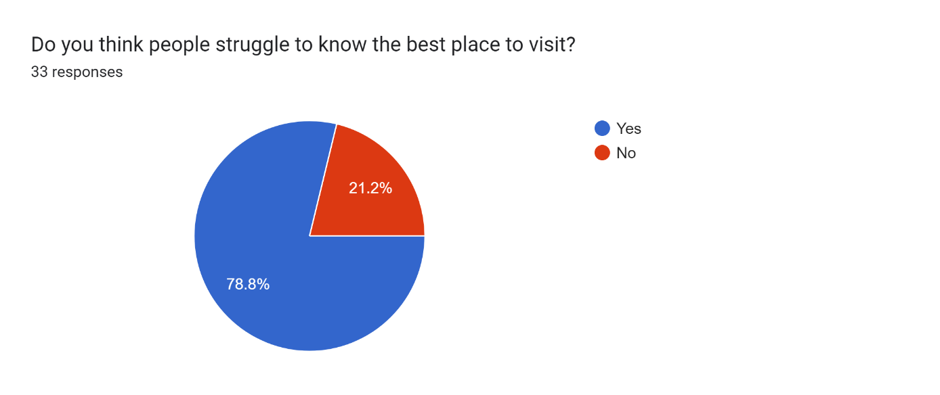

* **Improvement in Tourism**: There's an overwhelming consensus that a tour planner can improve tourism in Bahrain, which underscores the potential impact of ClickVenture on the market.

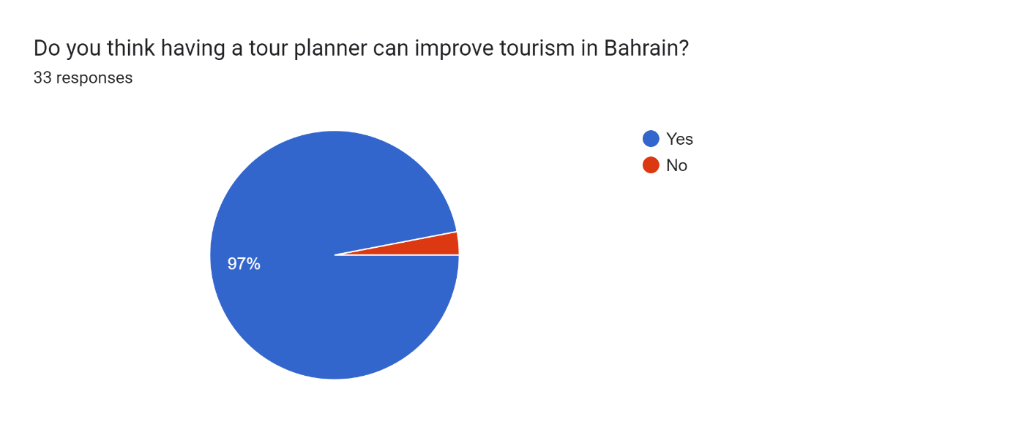

Based on these findings, ClickVenture can tailor its features to match the user profile that seeks a versatile platform offering recommendations for both dining and entertainment, with robust functionality for planning and sharing trips. The emphasis on user-friendly design, backed by AI to enhance trip customization, aligns with the respondents' openness to technology-assisted planning. The platform should prioritize building a social sharing mechanism that aligns with users' preferences to share their experiences with personal contacts.

These insights will directly influence the prioritization of features during development, ensuring that ClickVenture is well-positioned to meet the needs and preferences of its target audience.

* 1. **System Requirements**
     1. **Functional Requirements:**

|  |  |
| --- | --- |
| **Title** | **User Profiles and Registration** |
| **Description** | It should be possible for users to create accounts and customize their profiles to suit their tastes.  Users must have choices in the system to manage and update their personal data as needed. |

|  |  |
| --- | --- |
| **Title** | **Navigating and Searching** |
| **Description** | A comprehensive search feature that makes it easy for customers to find hotels, restaurants, attractions, and other pertinent institutions must be included on the website.  In order to improve user experience and support well-informed decision-making, it should have filters for focusing search results according to category, price range, location, and user ratings. |

|  |  |
| --- | --- |
| **Title** | **Interactive maps** |
| **Description** | It is essential to have interactive maps that show the locations of establishments and points of interest. It should be possible for users to plan routes and get directions using the maps, which would improve their platform navigation experience |

|  |  |
| --- | --- |
| **Title** | **Reviews and ratings from users** |
| **Description** | Users should be able to rate and evaluate businesses through the implementation of an organized system.  In order to preserve the authenticity and caliber of user-generated material and guarantee its dependability and credibility, moderation tools have to be included. |

|  |  |
| --- | --- |
| **Title** | **Mobile-Friendliness** |
| **Description** | To meet the wide range of user preferences and habits, it is imperative to make sure that the website is optimized for accessibility and usability across multiple platforms, especially mobile phones. |

|  |  |
| --- | --- |
| **Title** | **Integration of Social Media** |
| **Description** | The platform ought to enable users to effortlessly share their travelogues and discoveries on social media networks.  For user convenience, social network login integration should be offered, making the registration and login procedures more efficient |

|  |  |
| --- | --- |
| **Title** | **Trips Designed by Users** |
| **Description** | It is important to provide users with the means and capabilities to plan and alter their trips in accordance with their tastes and needs. |

|  |  |
| --- | --- |
| **Title** | **Automated System for Creating Trips** |
| **Description** | It is essential to put in place an automated trip creation system to help consumers create customized trip plans quickly and easily based on their inputs and preferences. |

|  |  |
| --- | --- |
| **Title** | **Points for Rewards System** |
| **Description** | To encourage user participation and loyalty, a reward points system that offers prizes or perks depending on user interactions and platform contributions should be included. |

**4.2.2 Non-Functional Requirements:**

These well-crafted non-functional requirements lay the foundation for a reliable, secure, and easy-to-use travel website, enhancing and building user trust.

|  |  |
| --- | --- |
| **Title** | **Description** |
| **Performance** | The website must respond quickly to user interactions and support concurrent access by numerous users without degradation in performance. Scalability is key to manage varying loads efficiently. |
| **Security** | Strong authentication and authorization procedures will be implemented to protect user accounts and personal data. The system will employ encryption to secure data transmissions. Especially important for vouchers and points counting. |
| **Reliability** | The platform will ensure high availability with minimal downtime, employing robust error handling and recovery processes to maintain continuous service. |
| **Usability** | The user interface will be intuitive and easy to navigate, designed to meet the needs of diverse users, including those with disabilities, ensuring accessibility and a positive user experience. |
| **Compatibility** | The system will be compatible across major web browsers and optimized for various devices to ensure a broad user reach and seamless experience across platforms. |
| **Regulatory Compliance** | The system will comply with applicable data protection and privacy laws, ensuring user data is handled securely and legally. |
| **User-Experience Design** | To improve overall happiness and engagement, user experience design should place a high priority on a smooth and pleasurable user experience.  It is important to regularly test for usability in order to find and fix any possible problems. |

* 1. **System Models**

// This section describes different system models, which can be implemented either using the traditional approach or Object-Oriented (OO) approach as shown in Table 1.

*Table 1: The system models.*

|  |  |
| --- | --- |
| Traditional Approach | OO Approach |
| * + 1. **Data Flow Diagram**   // This section describes the data flow diagram which explains how data is processed and transferred in a system. | **4.3.1 UML Use Case Diagram**  // This diagram describes the system’s boundaries and functionalities from the user point view. |
| * + 1. **Process Specification**   // This section describes the method used to document, analyze and explain the decision making logic and formulas used to create output data from process input data.  // This section may include also the description of the “Structured English” which details each step in the running process of the program. | **4.3.2 Process Specification**  // This section describes the use case descriptions and scenarios. In addition to,  UML sequence, state and activity diagrams for important processes should be included. |
| * + 1. **Entity Relationship Diagram**   // You illustrate here the information of a system’s entities and relationships between those entities. | **4.3.3 UML Class Diagram**  // This diagram describes the static structure of the system in term of classes. All relationships among classes should be represented. |

The Object-Oriented approach provides a robust framework for modeling and designing the ClickVenture system. Utilizing UML diagrams, we can represent the system both statically and dynamically, ensuring clarity and consistency in the implementation.

**OO Approach for ClickVenture:**

4.3.1 UML Use Case Diagram:

This diagram will define the system's boundaries and functionalities from the user's perspective, detailing the interactions between users (actors) and the system (use cases) to achieve specific goals, like creating a trip plan.

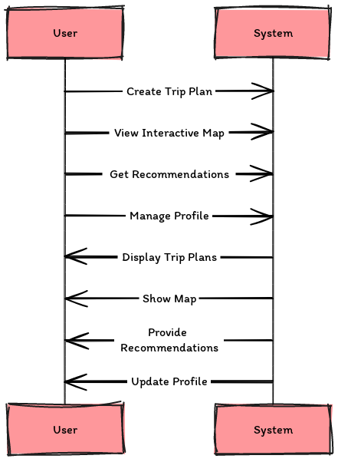

4.3.2 Process Specification:

The Process Specification section documents the use case descriptions and scenarios, providing clear insights into the steps the system undertakes in response to user actions. This documentation is supported by various UML diagrams that illustrate the order of interactions, system states during different scenarios, and the workflows within the system. Each diagram type contributes to a holistic understanding of user interactions with the ClickVenture system.

**UML Sequence Diagram:**

The UML Sequence Diagram details the series of interactions between the user and the system for creating a trip plan. Starting with the user logging in and proceeding through accessing the trip planner, entering details, selecting recommendations, and finally saving the trip plan, the diagram captures each step dynamically, highlighting the system's responses at every stage.

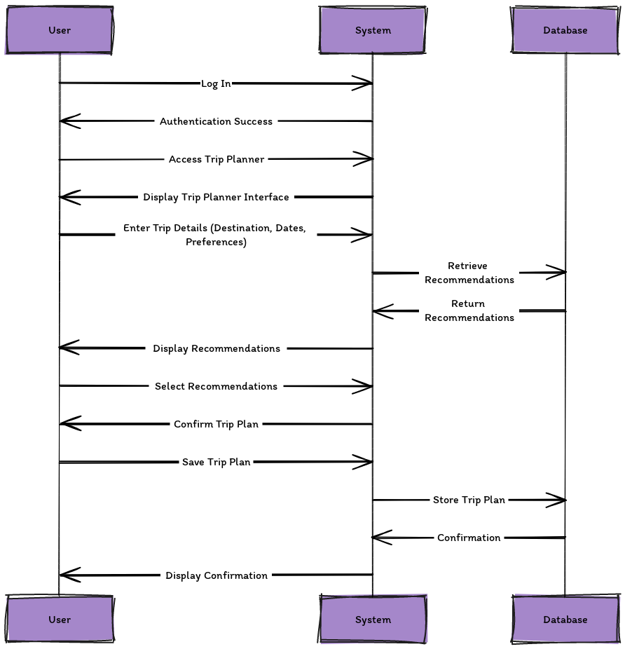

**UML State Diagram:**

The UML State Diagram reflects how the system's state changes in response to specific user actions and decisions throughout the process of trip planning. It depicts various states such as 'Logged In', 'Planning Started', and 'Plan Submitted', along with transitions based on user interactions like 'Log In Success', 'Start Planning', and 'Submit Plan'. This diagram is crucial for understanding the conditional flows and potential outcomes within the application.

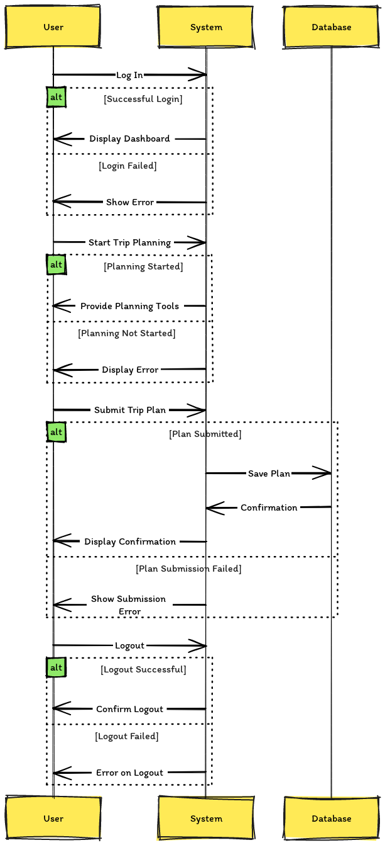

**UML Activity Diagram:**

The Activity Diagram provides a step-by-step breakdown of the system's workflow when a user engages in trip planning. It outlines critical activities like logging in, entering trip details, selecting options from provided recommendations, and submitting the finalized trip plan. This diagram emphasizes the sequence of actions and the flow of information across system components, showcasing how user inputs lead to specific outputs and system states.

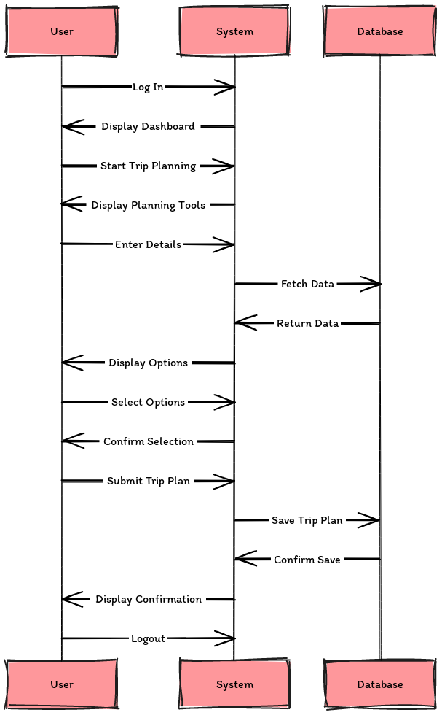

These diagrams collectively enhance the clarity of the system’s design and operations, making it easier to understand the user's journey through the ClickVenture application from a technical perspective. Each diagram serves a specific purpose in illustrating how the system handles and responds to user interactions, thus aiding in both system development and troubleshooting.

**4.3.3 UML Class Diagram**:

The UML Class Diagram provides a high-level overview of the ClickVenture system's structure. It outlines the main classes, their interactions, and the relationships between them, capturing the essence of the system’s architecture. This diagram is crucial for understanding how different parts of the application are connected and work together to support functionality:

* **User**: Represents the system users with methods for login and logout functionalities.
* **TripPlan**: Manages trip planning details and interactions, allowing users to create, update, and delete their travel plans.
* **System**: Acts as the intermediary, facilitating communication between the user and database, ensuring user validation, and generating trip recommendations.
* **Database**: Serves as the storage system for user and trip plan data, handling data persistence operations such as save, delete, and update.

The diagram also highlights the relationships such as usage, management, ownership, and data storage, providing a clear map of how each component of the system relies on and communicates with others.

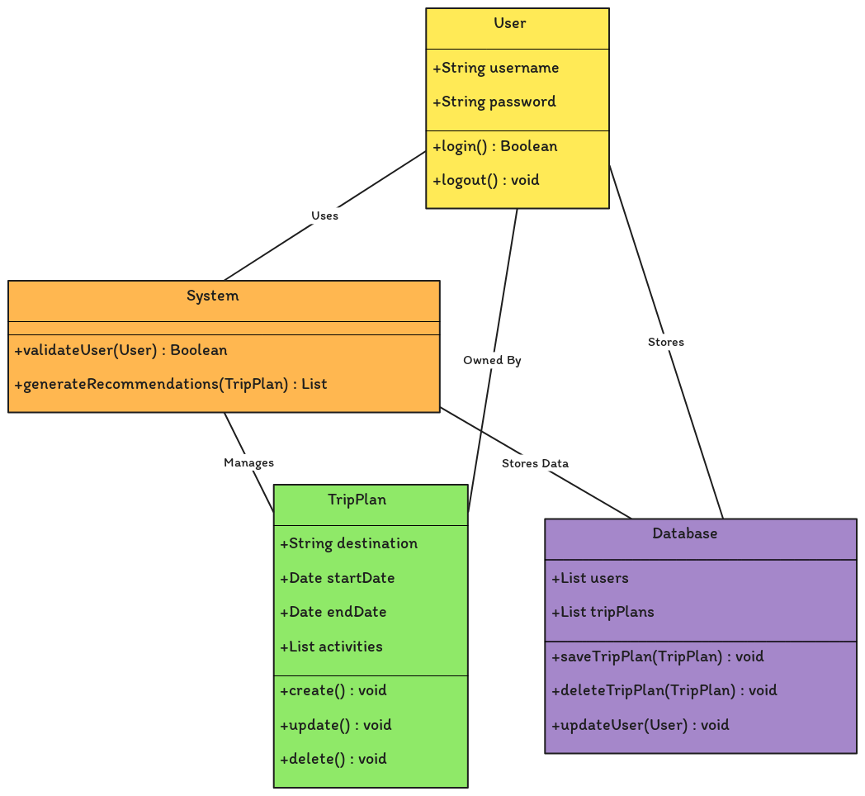

Chapter 5  
System Design

// This is a fundamental chapter in the report where the aspects of the system design is discussed and evaluated. This chapter could include **database schema, user interface design, procedure design, flow of the system, software algorithms, etc.**

// If you choose the OO approach, include a general description of the selected software architectural style. A justification of your selection should be included. A description of the system design in term of software architecture and architectural derivers should be included. In addition to, detailed UML diagrams, such as package, sequence, class, deployment diagrams can be included in this section.

// This chapter should start with an introduction followed by sections and eventually subsections.

A comprehensive blueprint of the complete system is generated during the critically important System Design phase of software development projects, which outlines all of the system's features, components, and overall structure. Regarding the ClickVenture concept, great thought has been given to it. The aim is to create a well-architected system that satisfies the requirements of its intended functionality while also aligning with project objectives.

* 1. UI Design:

The process of creating user interfaces (UIs) is dynamic and centered on creating interfaces that promote user experience and ease of use are highlighted below showing both Web View and responsive Mobile View side by side for each page:

|  |  |
| --- | --- |
|  |  |

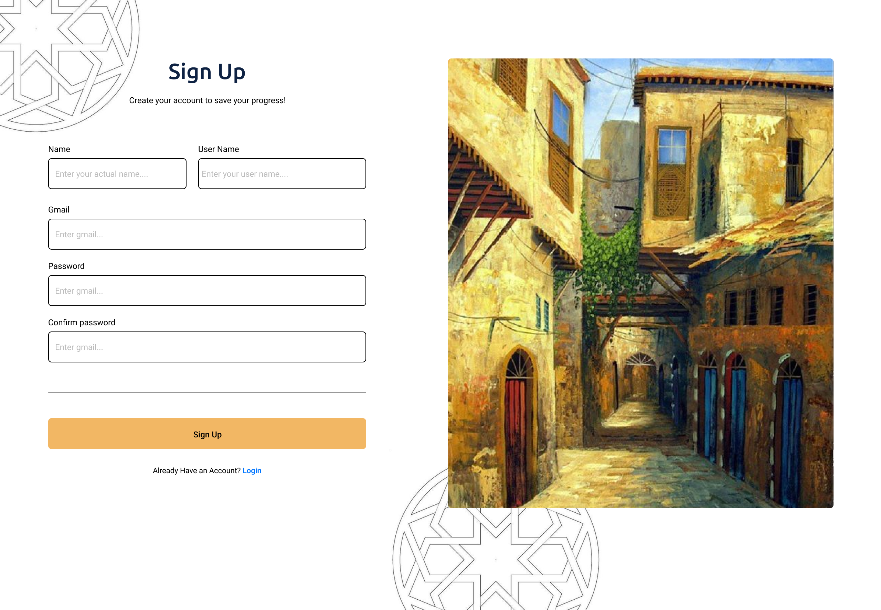

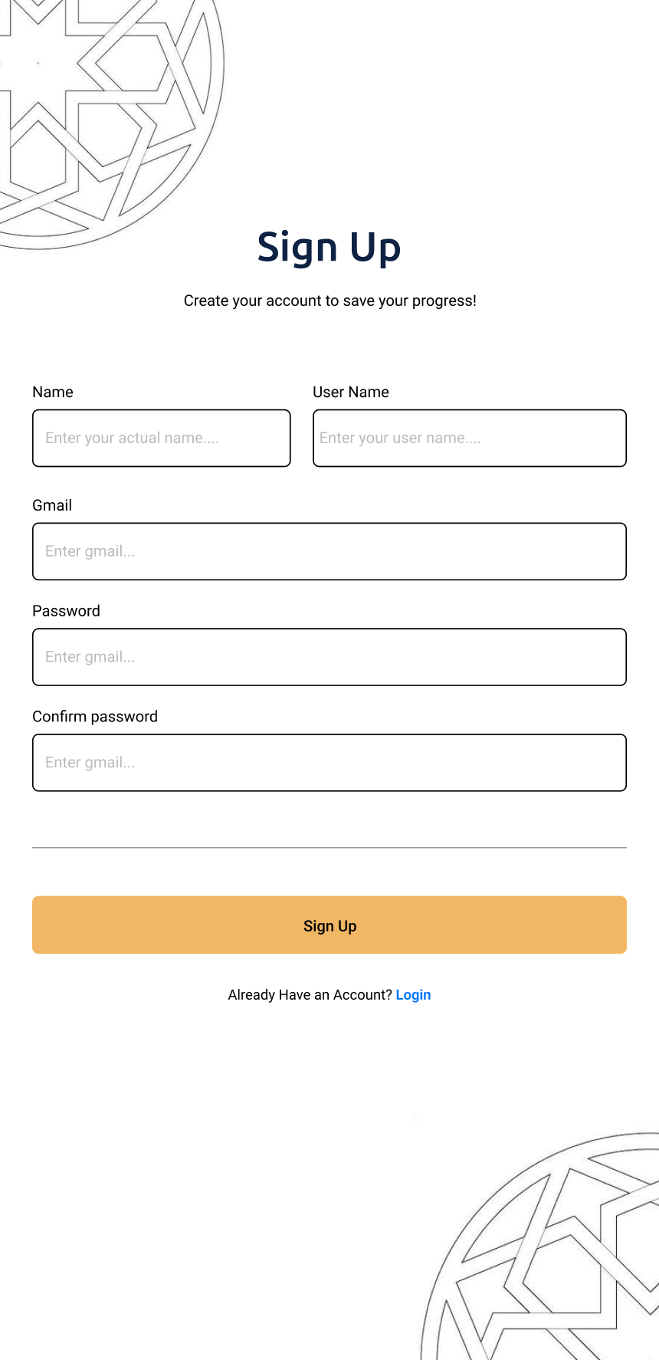

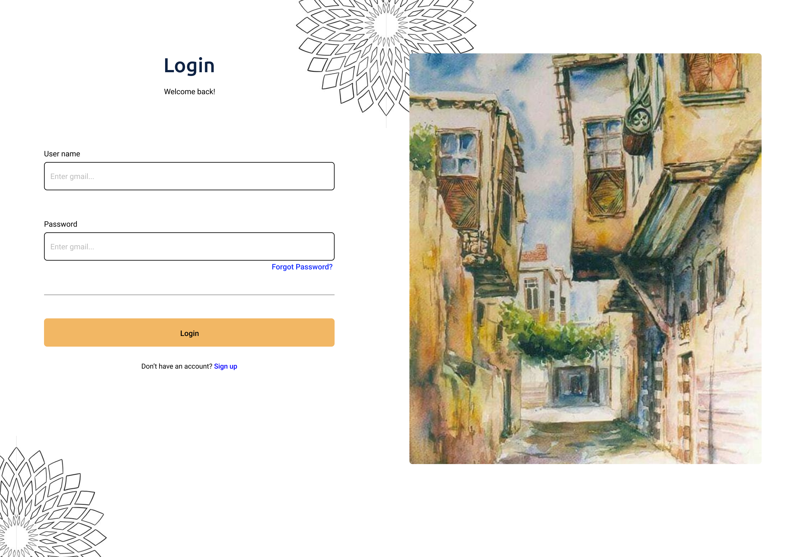

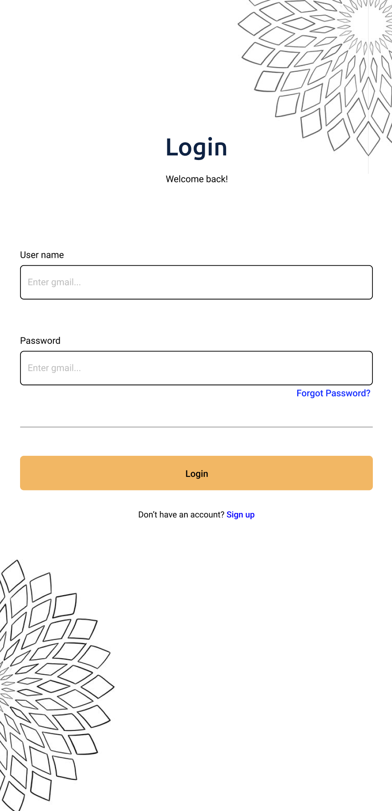

|  |  |  |
| --- | --- | --- |
|  |  | |
|  | |  |

|  |  |
| --- | --- |
|  |  |
|  |  |

|  |  |  |
| --- | --- | --- |
|  |  | |
|  | |  |

|  |  |
| --- | --- |
|  |  |

|  |  |
| --- | --- |
|  |  |

|  |  |
| --- | --- |
|  |  |

|  |  |
| --- | --- |
|  |  |
|  |  |
|  |  |
|  |  |

Chapter 6  
System Implementation and Testing

// This chapter describes the details of the system implementation into a working prototype. A description of how the different components are selected and integrated should also be included. Also, a justification of the implementation decisions such as used tools, hardware/software tools, algorithms, programming languages, cloud providers etc. should be provided.

// This chapter discusses the testing phases of the implemented system and reports the obtained results. A discussion of the results and comparison with similar systems including usability and user-experience testing should be added. A highlight of the strengths and weaknesses of the proposed system has to be included as part of this chapter.

// This chapter should start with an introduction followed by sections and eventually subsections.

Including usability and user-experience testing

# Chapter 7 Conclusion and Future Work

// The conclusion chapter should describe what have been done during the project as design, implementation and testing. Moreover, it should present a summary of the main results and findings and states the significances of them.

// This chapter can also include discussion about the project limitations, the implications of the project, and ideas for future work.

# References

// Insert here the references list.

// Any material used in the report that is taken from other sources MUST be referenced, such as ideas, concepts, phrases, information, processes or protocols, tables and figures, etc. You should follow the Harvard referencing style (click [here](http://libguides.murdoch.edu.au/IEEE) for a guideline).

* Pickyourtrail. 2024. Pickyourtrail [Online].

Available at: <https://pickyourtrail.com/us> [Accessed 2024].

* TripAdvisor. 2024. TripAdvisor [Online].

Available at: [https://www.tripadvisor.com](https://www.tripadvisor.com/) [Accessed 2024].

* Unipal. 2024. Unipal [Online].

Available at: <https://unipal.me/en-bh/> [Accessed 2024].

* Smith, A. and Johnson, B., 2023. Engagement and personalization in travel platforms: A data-driven approach. *Journal of Travel Research*, 62(4), pp.556-572.
* Lee, C., Kim, S. and Park, H., 2022. The impact of user interface design on user satisfaction in the travel and tourism industry. *Tourism Management Perspectives*, 39, pp.100784.

Appendix A  
Compact Disk material

// Remove this appendix before submission.

// A CD should be attached with the report. The CD should include:

1. The project report (.docx and .pdf formats)
2. The project poster (.ppt format).
3. Arabic Abstract (.docx format) as a separate file (Do not include in the report).
4. Pictures, and demo videos related to the project
5. The codes and sketches used in the project.

The CD should be clearly labeled with the

1. Title of the project
2. Students’ names and students’ IDs
3. Supervisor(s)’ name(s)
4. Academic year and semester of defending the project.

Appendix B  
Format Guideline

Font Styles

For different items of the report there are different font styles. This document has been set with the main required styles. Use **Error! Reference source not found.** to see all the different setup required for the report with their pre-set styles. The pre-set styles (we going to refer to them later as “styles”) are set to make your report formatting easy.

To set a style for certain title, heading, or paragraph just select the item and select the proper style from the style pane. For more information on how to apply styles click [here](https://support.office.com/en-us/article/apply-styles-f8b96097-4d25-4fac-8200-6139c8093109?ui=en-US&rs=en-US&ad=US), then read and watch the available video.

Table 2: Fonts and Styles.

| Usage | Style Name | Font/size | Type | Alignment | Spacing | Indention | Other |
| --- | --- | --- | --- | --- | --- | --- | --- |
| Main title | Title | TNR/22 | Bold | Center | Single | - |  |
| Subtitle | Subtitle | TNR/18 | Bold | Center | Single | - |  |
| Main sections | Main Sections | TNR/18 | Bold | Center | Single  After: 12pt | - | In a new page |
| Table of contents title | General Titles | TNR/18 | Bold | Center | Single  After: 12pt | - | In a new page |
| Chapter Titles | Chapter | TNR/18 | Bold | Center | Single  After: 12pt | - | In a new page |
| 1st level heading | Heading 1 | TNR/14 | Bold | Left | Single  Before: 6 pt After: 3 pt | - | numbered |
| 2nd level heading | Heading 2 | TNR/13 | Bold | Left | Single  Before: 3 pt After: 3 pt | Before: 5 pt | Numbered |
| 3rd level heading | Heading 3 | TNR/12 | Bold | Left | Single  Before: 3 pt After: 3 pt | Before: 10 pt | Numbered |
| 4th level heading | Heading 4 | TNR/11 | Bold | Left | Single  Before: 3 pt After: 3 pt | Before: 13 pt |  |
| Appendix Header 1 | App heading 1 | TNR/14 | Bold | Left | Single  Before: 6 pt After: 3 pt | - | Not numbered |
| Appendix Header 2 | App heading 2 | TNR/13 | Bold | Left | Single  Before: 3 pt After: 3 pt | Before: 5 pt | Not numbered |
| Appendix Header 3 | App heading 3 | TNR/12 | Bold | Left | Single  Before: 3 pt After: 3 pt | Before: 10 pt | Not numbered |
| Regular text | Body text | TNR/11 | Regular | Left | Spacing:1.5  Before: 3 pt After: 3 pt |  |  |
| Captions | Caption | TNR/9 | Italic | Center | Single  After: 10 pt |  |  |
| Coding | Code | Courier/10 | Regular | Left | Spacing:1.15  Before: 9 pt After: 9 pt | Before: 20 pt  After: 20 pt | No spacing between similar paragraph |

Font is Times New Roman for all fonts in **Error! Reference source not found.** except for coding

Coding

The “code” style is set to be applied to any code inserted in the Report. Check the following code.

print "Hello World!"

print "Hello Again"

print "I like typing this."

print "This is fun."

print 'Yay! Printing.'

print "I'd much rather you 'not'."

print 'I "said" do not touch this.'

This style uses Courier as the font; it is 10 pt in size; uses spacing of 1.15; moreover, it adds 3 pt spacing before and 3 pt spacing after the code (only between the code and different style of text).

Captions

Use MS Word captions to add captions to tables, figures, equations, and other objects. The table captions should be above the table, and for figures it should be below the figure.

Insert Captions

Click [here](https://support.office.com/en-us/article/add-format-or-delete-captions-in-word-82fa82a4-f0f3-438f-a422-34bb5cef9c81?ui=en-US&rs=en-US&ad=US) for guide on how add captions Word.

Cross-referencing

Click [here](https://support.office.com/en-us/article/create-a-cross-reference-300b208c-e45a-487a-880b-a02767d9774b) for a guide on how to create cross-reference.

Updating the tables

Before printing the report, make sure the all the tables on the front matter (table of contents, of tables, and of figures) are updated. The contents of those tables are updated automatically. Click [here](https://support.office.com/en-us/article/update-a-table-of-contents-6c727329-d8fd-44fe-83b7-fa7fe3d8ac7a) for more information about how to update those tables.

Titles of main sections/chapters

All main titles are similar in the font settings, which are 18-pt bold centered TNR, and they differ in other setup settings. Therefore, there are different styles for different titles. The following subsections describes those formats.

Front matter and References

These are all titles of the main sections coming at the front matter of this report and before the Introduction chapter and the reference section after the conclusion chapter. These sections include the acknowledgment, table of contents, and table of figures. The titles of all those sections should be of a single line. All titles of those titles, except “table of contents”, uses “Main Sections” as their style. However, the title “table of contents” uses “General Titles” as its style.

Chapter titles

These are at the main headings of the main body sections; they start with the Introduction chapter and ends with the Conclusion chapter. The used style for chapter titles is called “Chapter”.

The chapter heading starts automatically with the word “Chapter” followed by a space, Arabic number. These parts will be added automatically once the “Chapter” style has been chosen. Then a soft return should be added and then the actual chapter title. The soft return divides the chapter title into two lines, as shown in **Error! Reference source not found.**; however, both lines will still be considered as one item. To enter a soft return press both the shift and return keys at the same time.



Figure 1: Main body chapter title

Appendix titles

They are the main heading of the appendices; they come after the Conclusion chapter. The appendix heading starts with the word “Appendix” followed by a space, an alphabetic letter, soft return, and then the actual appendix title.

Pagination

The page numbering starts from the cover page until the last page of that report. However, the first part of the report has different pagination system than the second part. The page numbers are placed at the bottom of the pages on the right side.

The cover page and front matter (first part) use roman numbers. However, the cover page number (i) should be hidden.

The remaining of the report (chapters and appendices) use Arabic numbers. The numbering starts from the first chapter (Introduction) with page number 1. This numbering will carry out until the end of the report.